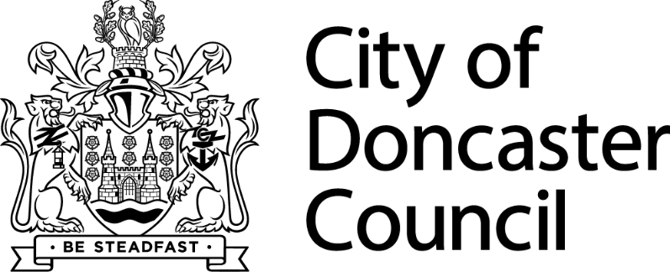
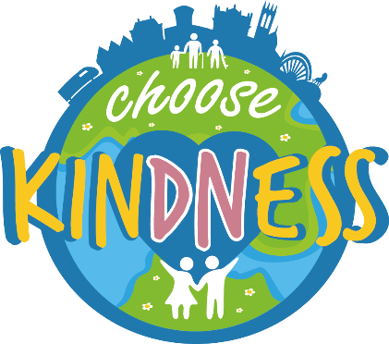

Community Development Support Fund Anchor Organisation

Guidance Notes

About the Grant
One kind act can spark another. It can brighten a grey day, touch a stranger’s heart and inspire a chain reaction of kindness. Doncaster’s Choose Kindness movement celebrates and champions kindness across the city and the fantastic community spirit that has shone through in the toughest times.
There is no limit to the benefits of choosing kindness and the powerful difference this makes to people, place and planet.
To build upon this, we have 4 grants of up to £25,000 available, one per area of Doncaster. The grants are available to support local community anchor organisations who provide a friendly, inclusive and welcoming environment for all members of the community, regardless of their background, race, religion, gender or age etc, to come together for a chat, take part in a range of activities and receive support. We want to see activities which are inclusive, create community cohesion, understanding and respect for each other. This could be new activities and projects, extending current provision so more members of the community can be supported or continue existing provision.
Grants of up to £1,000 for smaller organisations or activities will be available in due course.
Examples of themed activity includes:
- Improving digital skills
- Mental health and wellbeing activities
- Language classes
- Arts and craft activities
- Cultural and heritage sessions
- Employment support
- Housing support
- Family support
What is a community anchor organisation?
Anchor organisations are independent community-led organisations operating in a local area, they are firmly rooted with a sense of place, and committed to positive economic, social or environmental change in that place.
They are flexible and innovative, so can respond and evolve as people’s requirements change, building trusted relationships that strengthen over time. There is diversity in what they do, but all anchor organisations are underpinned by a strong ethos of self-help and self-reliance. They share the belief that community regeneration is achieved through community-owned enterprise and that this is the best and most sustainable way to build strong and sustainable communities.
Community anchor organisations provide added social value in their services through making best use of local assets. This means, involving volunteers, bringing in inward investment and using local suppliers and creating local jobs.

Community anchor organisations have experience is delivery a range of activities and projects to support the local community with a variety of different needs. They can support smaller local groups to work in collaboration with a common interest.

Criteria
Applicants need to be able to evidence their role as an established community anchor organisation as outlined above.
Organisations must be either:
- a constituted group
- UK registered charity
- community interest company
- social enterprise organisation
- credit union
- not-for-profit company limited by guarantee

Community interest companies and social enterprise organisations must have a governing document, which shows the name, aim/purpose, objects of the group, including a dissolution clause.
Applications must evidence how the service has already been addressing at least one economic, social and environmental challenge, why this is a challenge within Doncaster communities, and the impact of the service in creating and contributing to positive change.

Who can apply?
This grant is available to the following groups in Doncaster:
- Not-for profit voluntary or community organisations
- Registered charities
- Faith-based organisations
- Not-for profit companies, community interest companies or social enterprises

How much is the grant?
You can apply for a maximum of £25,000, but there is no minimum amount. Only one grant per organisation.

We are unable to fund ideas that are:
- Activities promoting religious beliefs.
- Political activities.
- Goods or services that have already been purchased or ordered.
- Activities outside of the Borough of Doncaster.
- On-going organisational running costs.
- Trips and holidays.
- Costs that are already included within and funded by an existing grant or contract.
- School activities that are included within the curriculum (activities led by schools that engage the community will be eligible/considered).
- Endowments / loan repayments.
- Items that can only benefit an individual.
- Capital Costs.
- To establish a grant system overseen by the recipient organisation
- Costs where there is a statutory duty to provide them: including bad debts, advance payments, insurance policies, working capital, lease costs, pensions, and reclaimable VAT.

Evaluation and celebrating success
We want to help raise the profile of the great work that is taking place throughout Doncaster’s communities. To help us do that, all successful applicants must be willing to share a case study (this could be written, photos, short video etc) and a short questionnaire with Doncaster Council 6 months after funding has been allocated whilst engaging with Well Doncaster Officers for monitoring purposes.

When is the deadline to submit applications?
The deadline for Anchor organisations is the 29th of April 2024.
Please submit all applications to Community.WealthBuilder@doncaster.gov.uk.

What happens when you submit your application?
- You will receive an acknowledgement email which will have your unique reference number on it within 2 working days of submitting your application.
- You may be contacted by City of Doncaster Council to discuss your application in more detail.
- Applications will be assessed, and decisions given via email by City of Doncaster Council
- Monies will be transferred to your bank account once a signed grant agreement is in place, please note that this can take up to 30 days to reach your account.
- By accepting receipt of the fund, you must be willing to engage with the Community Wealth Builder Team and return any paperwork required.
- Your local Well Doncaster Officer can provide support – keep in touch with them to let them know how you are doing.
- The grant must be used within 12 months of receiving the money.

Unsuccessful applications
Unsuccessful applicants will be given feedback on their application and provided with recommendations from the panel. Unsuccessful applicants can reapply at any time, for support in this please contact the Community Wealth Builder Team.

